Name: Majid Ali
Section: Software Engineering (A)
Course: Networking
CMS ID: 053-25-0017

Activities
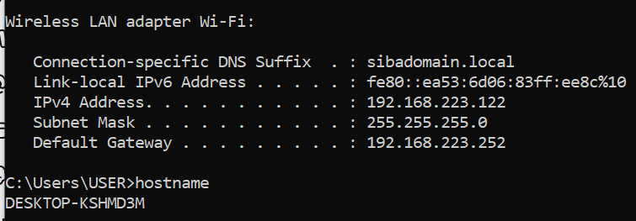
Network Interface 1. Know your communication interface unplug the RJ 45 or ethernet cable or UTP cable replug the connector and observe the connectivity process Now find following host name of your PC

______________________________________________________________________________

# of interfaces (virtual and physical)
4 interfaces (physical 2 Virtual 2)
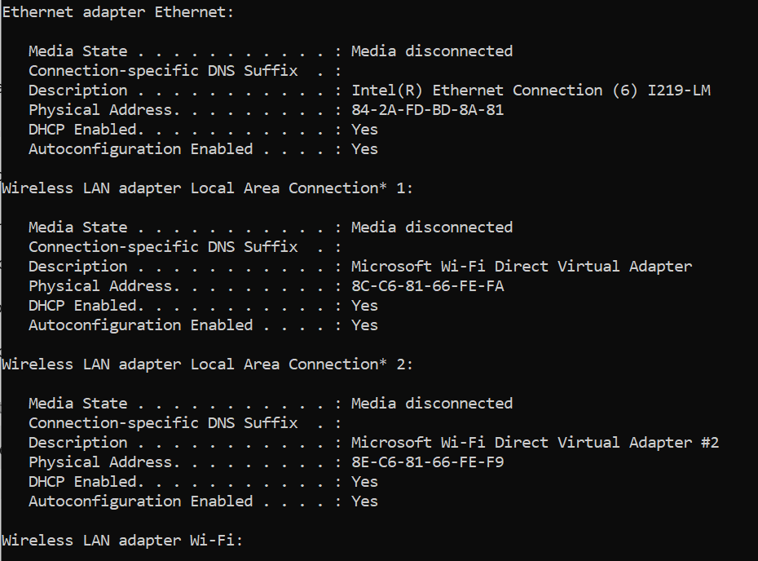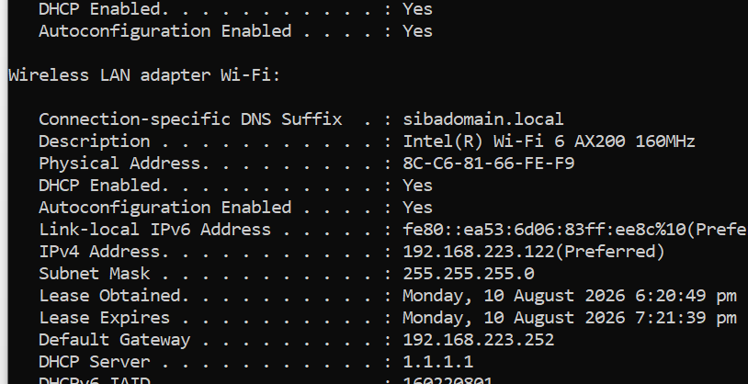
______________________________________________________________________________
IP address of your PC
______________________________________________________________________
DNS server : how many? which is primary? which is public and which is private Lets ping our neighbors ping an IP (Both are
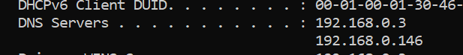 ______________________________________________________________________________
ping a hostname
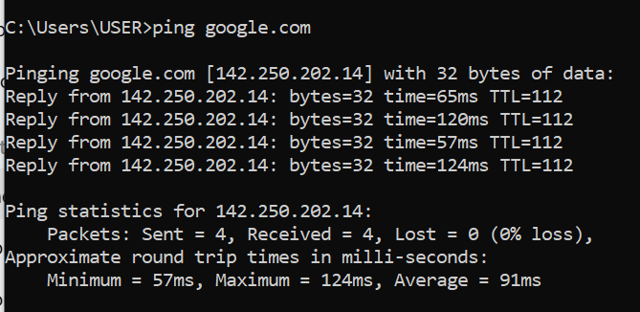 ______________________________________________________________________________

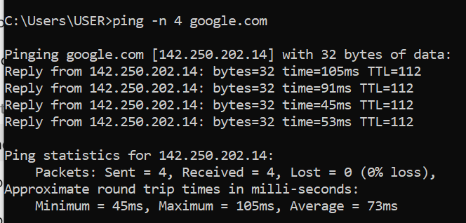
ping with -n
_________________________________________________________________________
ping with –t
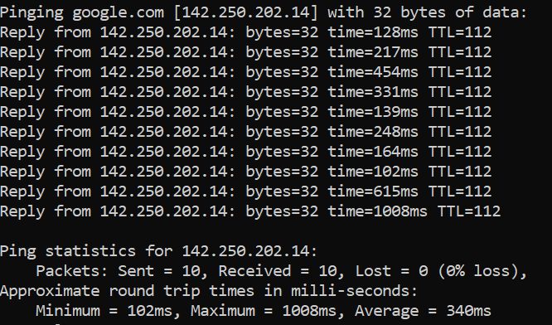
__________________________________________________________________________
lets use name server (dns) to know IP address of www.centralasian.uz
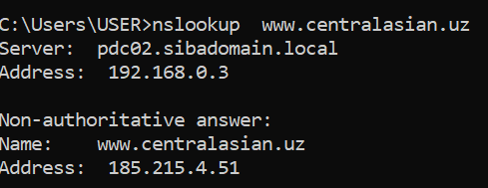 __________________________________________________________________________
lets trace www.google.com



